Purpose:
To provide a step by step guide to collect UAS data using the DJI GS Pro (Ground Station Pro) application.
Procedure:
- Prepare

Refer to Preflight Checklist

Click here to access Checklist.

Select JPG images in DJI app

Launch DJI GS Pro APP

Click on the bottom left "New" button

On the new mission screen select "3D Map Area" Click "Tap"

Tap and hold the middle of the area of interest and dragging the solid white points to the edges of the area of interest.

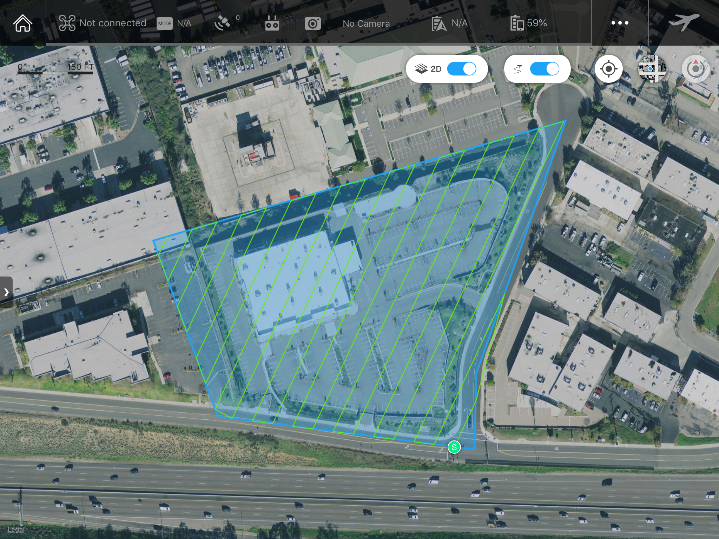

On the right column under the "Basic" tab select the follow:

Camera Model chose the appropriate camera and lens.

Shooting Angle select Parallel to Main Path.
Tip: Parallel to Main Path: The camera is parallel to the main path, i.e. the angle of the camera pan axis is the same as the angle of the main path. The pictures captured on the main path will be put in order as shown.

Capture Mode select Capture at Equal Dist. Interval.
Tip: In Capture at Equal Dist. Interval / Time Interval Modes, the aircraft will not hover during capturing as it flies along the main path. The capture interval is calculated automatically according to the overlap ratio and other parameters. The flight speed is calculated automatically according to the camera features and the altitude (resolution) setting. In this mode, operation is fast. However, short exposure times are required.

Flight Course Mode select Scan Mode.
Tip: Scan Mode generates a flight course by scanning line by line. For a concave polygon, the course may be beyond the area boundaries.

Altitude at 164ft

Tip: Enter your desired altitude, keeping in mind that higher altitudes can cut down on operation time but will have lower resolution. Always fly under 400ft when operating under Part 107 rules and regulations

Under the “Advanced” tab select the following:

Front Overlap Ratio set at 80% (see the figure on the next page for more details)
Tip: The higher the overlap the easier it is to process the images in AgiSoft Photoscan.
The overlap ratio of two consecutive pictures captured along the same main path. This is defined as 90% by default and can be set from 10% to 99%.

Side Overlap Ratio set at 80% (see the figure on the next page for more details)
Tip: The higher the overlap the easier it is to process the images in AgiSoft Photoscan.
Overlap ratio of two pictures on two parallel main paths. This is defined as 60% by default and can be set from 10% to 99%.
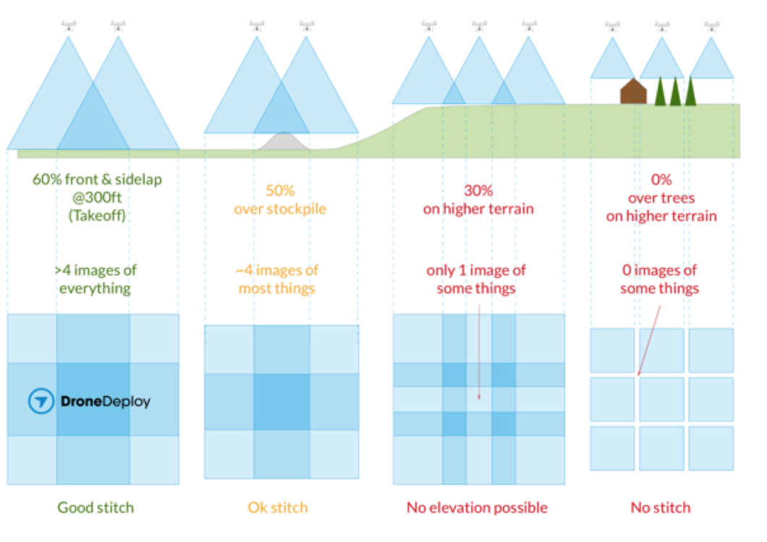

Course Angle set to 65°
Tip: The angle of the main path. East is 0°, with a positive value when it is counterclockwise and a negative value when it is clockwise. The range can be set from 0° to 360°.

End-Mission Action set to Return to Home

Information displayed above the Basic and Advanced tabs will give you more information on the overall mission.
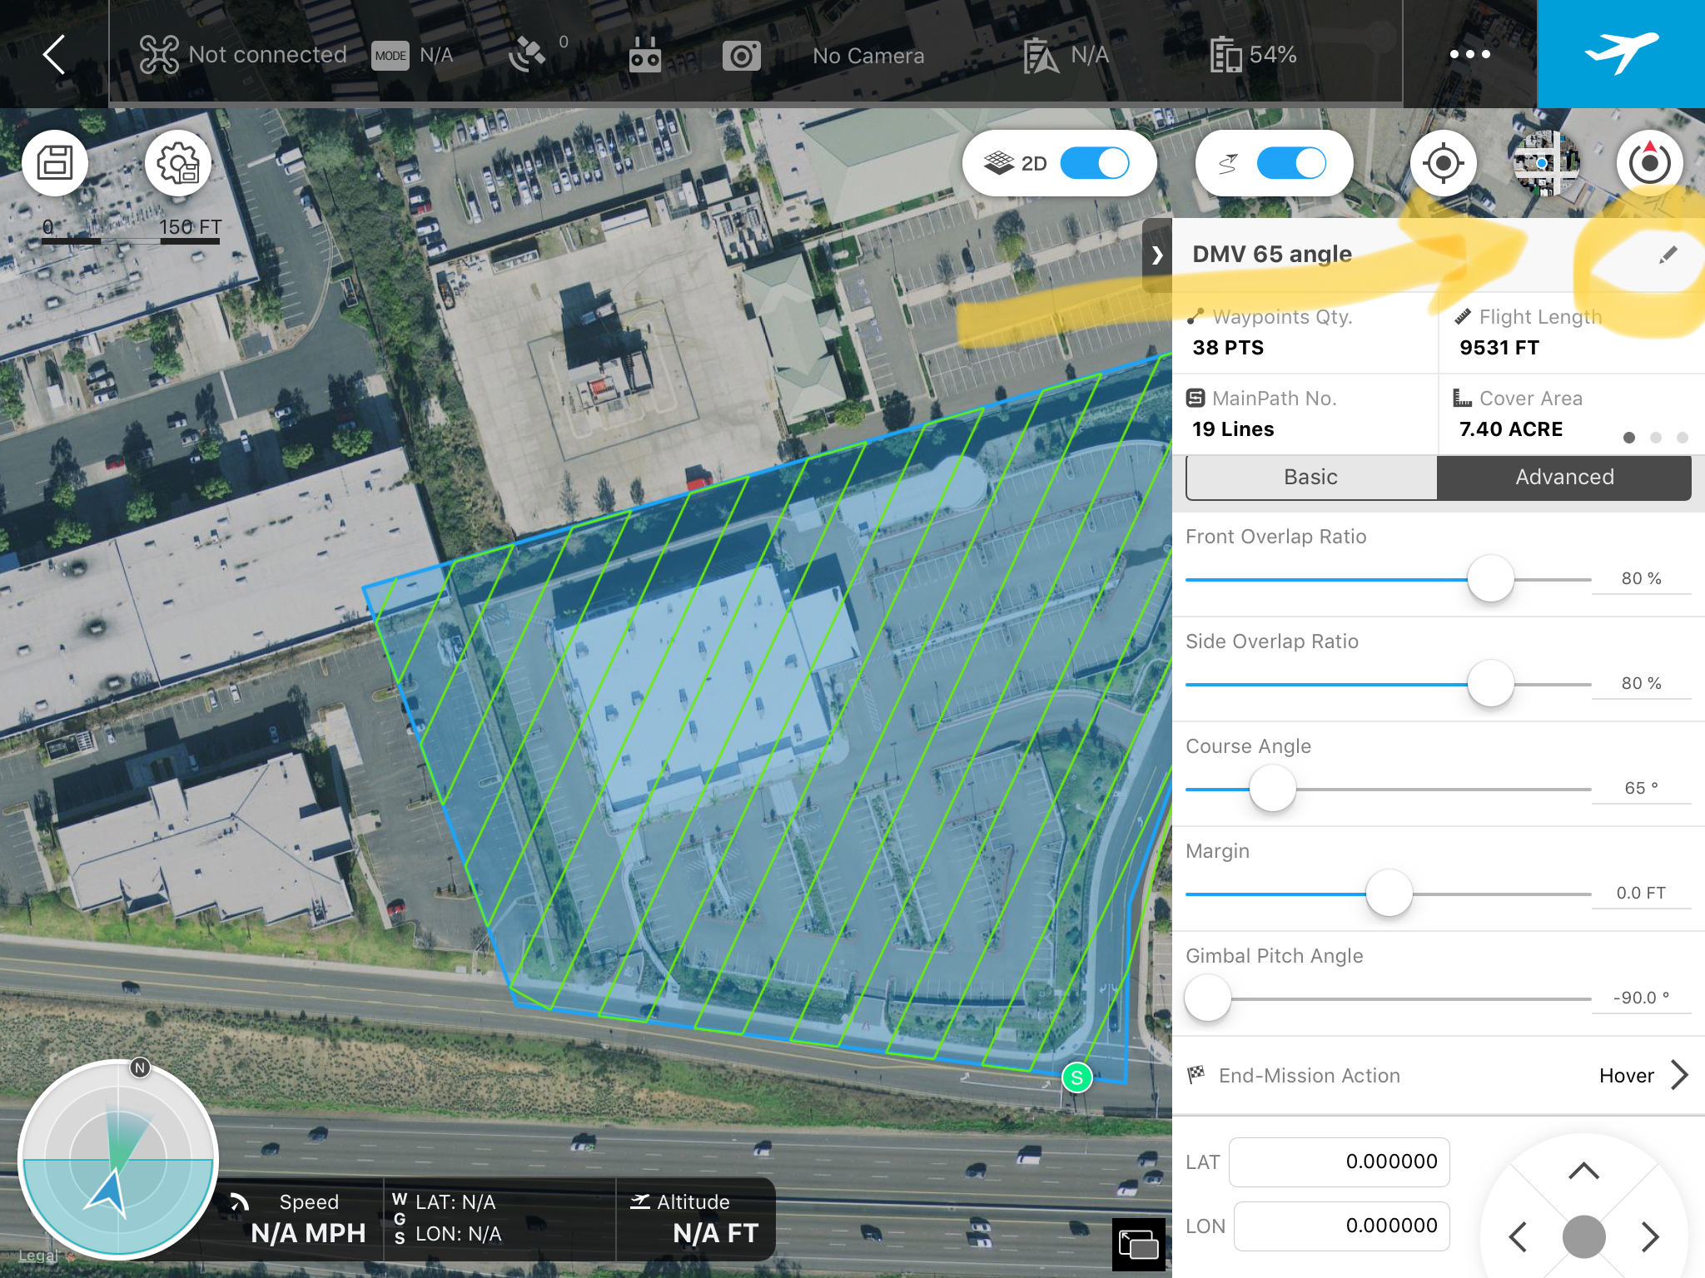

Save mission by clicking the save disk icon located on the top left of the screen.
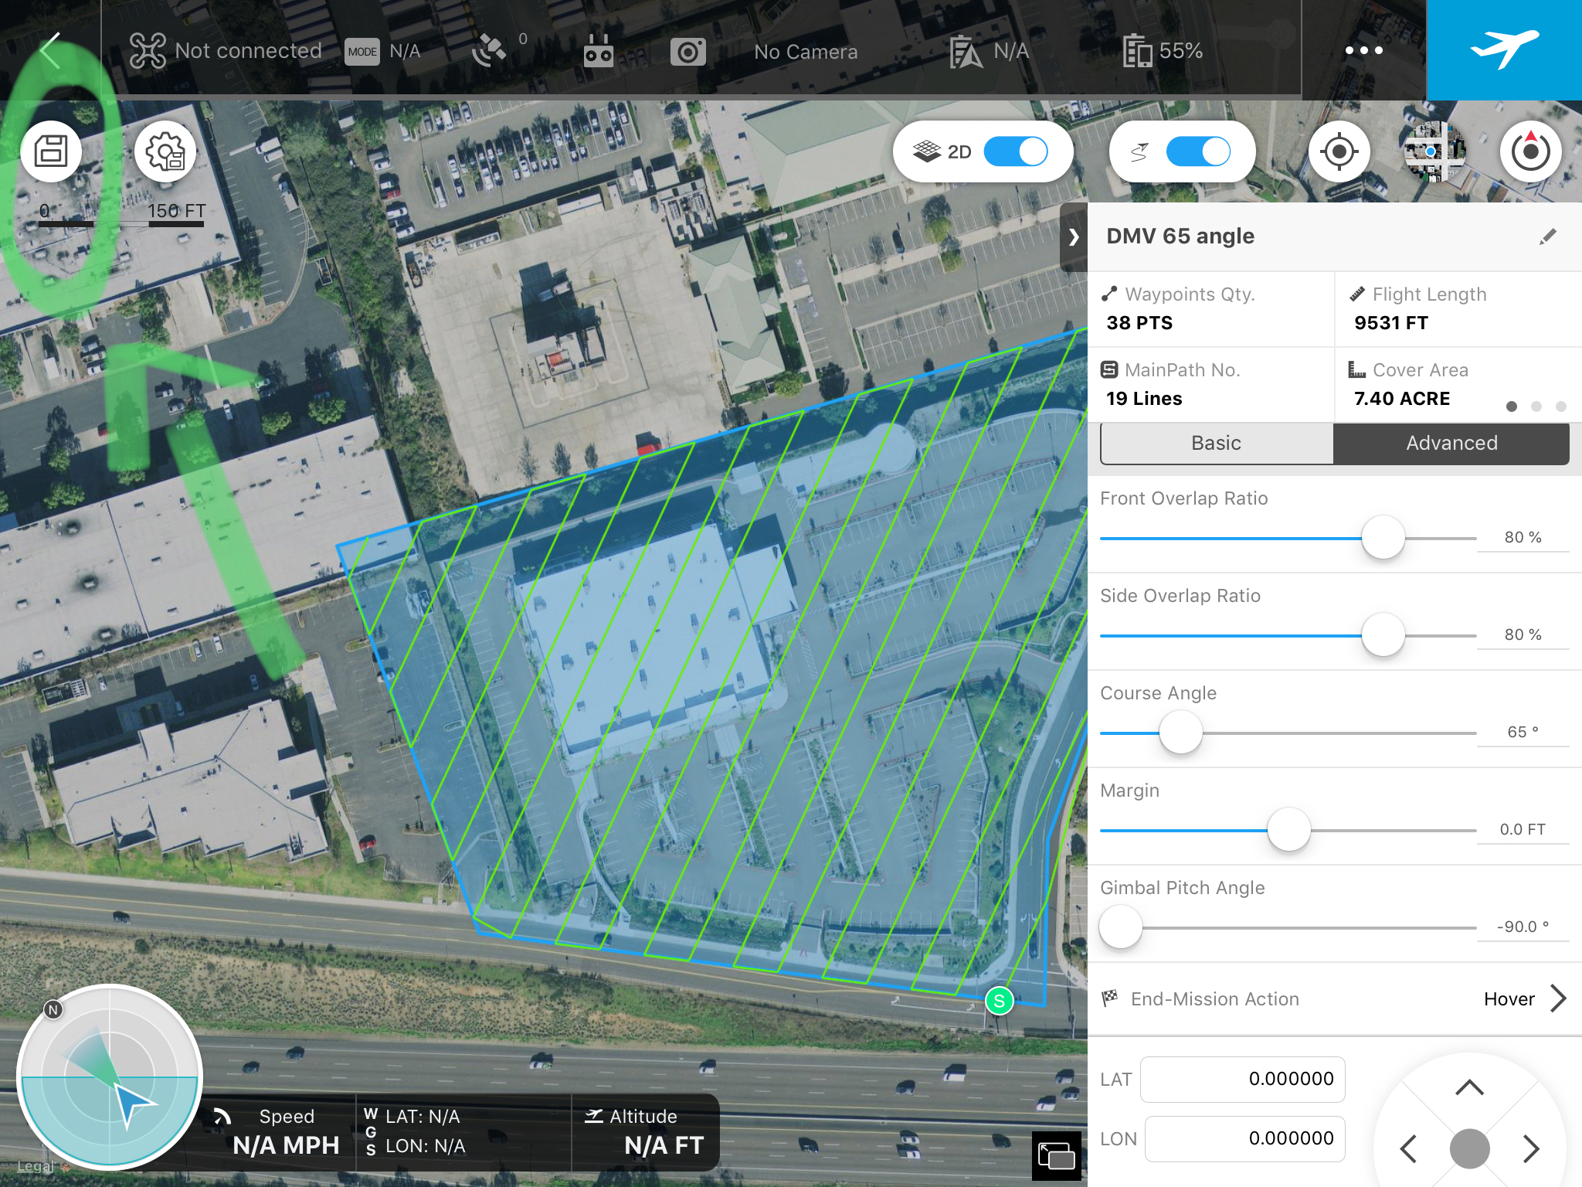

When ready to launch mission click the blue box with an airplane icon on the top right of the screen.

  - REPEAT THE MISSION WITH A DIFFERENT COURSE ANGLE

    - After the mission has completed. Adjust the Course Angle in step 1.2.5.3 to collect additional data 90° from original course angle of 65°. That is, enter 155° (65° + 90° = 155°).

Tip: The purpose of repeating the mission with a different course angle is to get different perspectives of the objects in our study area.

    - Rename, save and launch new mission.

  - PROCESSING YOUR DATA

    - Process your data by following the instruction in the Standard Operating Procedure for Processing Data Using Agisoft Photoscan.

Credit:

DJI GS PRO User Manual V1.0 2017.01
https://dl.djicdn.com/downloads/groundstation_pro/GS_Pro_User_Manual_EN.pdf

DroneDeploy: Mapping varied elevations, tall buildings or trees
https://drive.google.com/file/d/1pk9e6-fzWvy-ORg9c0pdadFsl_mSTMu_/view?usp=sharing

This resource was created with support from the National Science Foundation under Grant ATE #1700552. Any opinions, findings, and conclusions or recommendations expressed in this material are those of the author(s) and do not necessarily reflect the views of the National Science Foundation.

Attribution-NonCommercial-ShareAlike
CC BY-NC-SA

