Purpose:

To collect data that can be used to assess vegetation health in Richmar Park utilizing a Normalized Difference Vegetation Index (NDVI) sensor.

Equipment and Software:

DJI Inspire 1 with Zenmuse X3 camera gimbal customized with NDVI filtered lens to capture digital images of the 1.8 acre park.

DJI Go app for configuring drone’s compass and camera.

Maps Made Easy app to plan the mission.

Adobe Bridge program for renaming and organizing collected data.

Procedure:
- PREPARE
  - Perform pre-flight check: Click here to access the pre-flight checklist.

- COMPASS AND CAMERA CONFIGURATIONS
  - Launch the DJI Go App
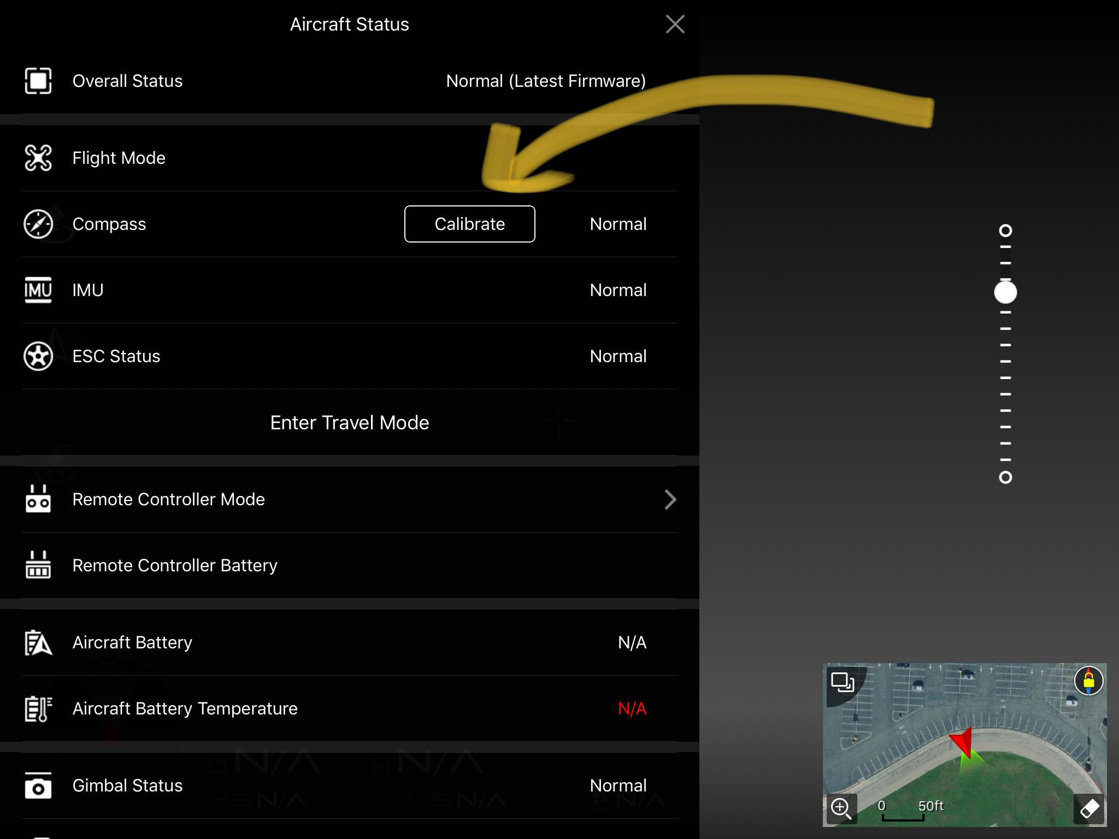
  - Connect remote controller to drone
  - Select GO FLY
  - Access the Aircraft Status window by click on the status bar near the top left, click Compass > Calibrate (if necessary; see right)
  - Adjust camera settings if desired, and exit the DJI Go App.

- MISSION PLANNING WITH MAPS MADE EASY
  - Open the Maps Made Easy App
  - Click Create New Mission.
  - Double tap a desired location to set your takeoff point (purple point).
  - Single tap the screen to create each vertex (orange point) for your study area.
  - Tap the black bar near the top of the screen to set the overlap, camera control, and other settings.
  - Once your desired settings are entered, tap the Airplane icon to upload and start your mission.
  - Once finished, the aircraft will land at the designed takeoff point or you can manually land it as well.
For more detailed instructions on configuring various settings in the Maps Made Easy App, please review section 2.0 of Terrain Aware Mission with Maps Made Easy.

- ORGANIZING YOUR IMAGES WITH ADOBE BRIDGE
  - Upload your images to a folder on the computer.
  - Open Adobe Bridge.
  - Select the folder which contains your images.
  - Select tools (near the top left of the screen), and pick Batch Rename
  - In the Batch Rename window, within the New Filenames area, enter the information in the following graphic. This will include the date and an unique sequence number in the name for each photo.

For example, if the first photo for the mission was taken on 1/1/1900, the new filename of the photo will be “Project_19000101_0001”.

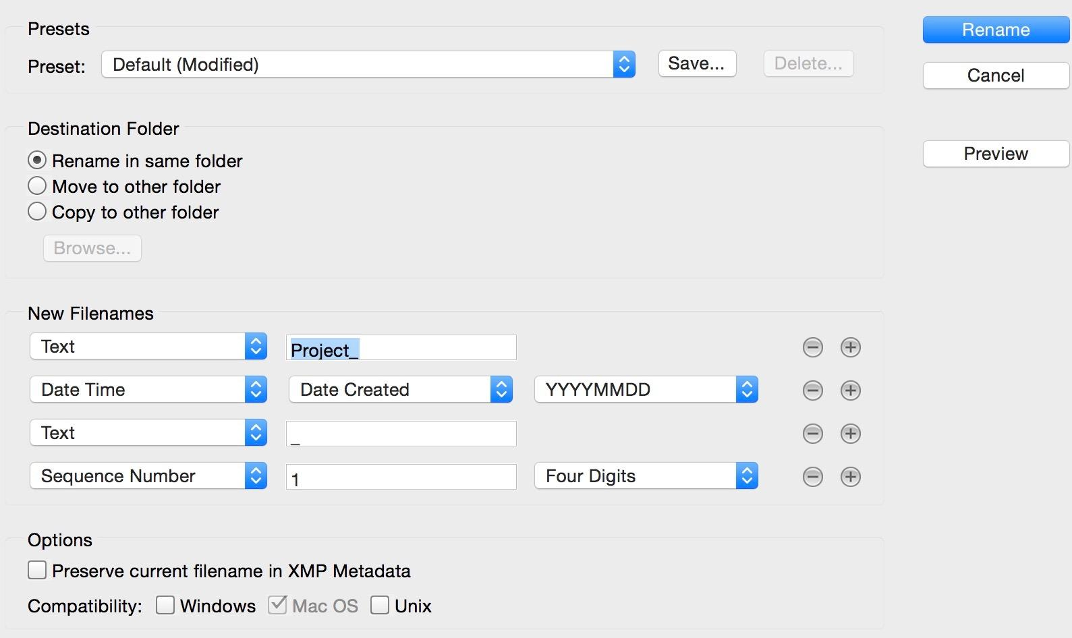
  - Hit Rename.

- DATA PROCESSING
  - Learn how to process your data with Agisoft Photoscan Pro by reviewing the instructions in Introduction to Drone Data Processing.

This resource was created with support from the National Science Foundation under Grant ATE #1700552. Any opinions, findings, and conclusions or recommendations expressed in this material are those of the author(s) and do not necessarily reflect the views of the National Science Foundation.

Attribution-NonCommercial-ShareAlike
CC BY-NC-SA

