Purpose:
To provide a step by step guide to process UAS data to create Orthomosaic, DEM (digital elevation model) and 3D model files using Agisoft PhotoScan.
Procedure:
- OPEN AGISOFT PHOTOSCAN PROFESSIONAL

Upload images

Click Workflow tab
    - Add folder
    - Select folder to process
    - Select Create camera from each file
    - Click OK

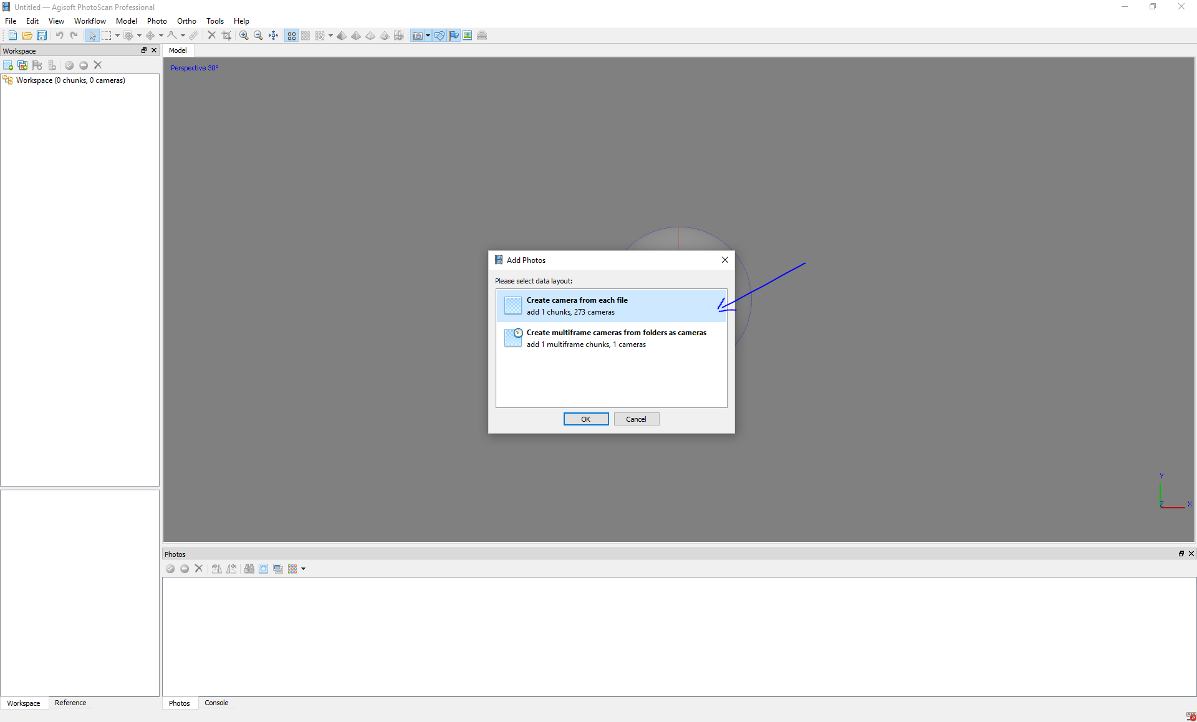

  - Align Photos
    - Click Workflow tab
    - Select Align Photos
    - Select Medium Accuracy
Tip: Higher accuracy setting helps to obtain more accurate camera position estimates. Lower accuracy setting can be used to get the rough camera positions and will take less time.
    - Click OK

  - Batch Process
    - Click Workflow tab
    - Select Batch Process
    - Click Add
    - Select Optimize Alignment for Job type
Tip: To achieve higher accuracy in calculating camera external and internal parameters and to correct possible distortion (e.g. “bowl effect” and etc.), optimization procedure should be run.
    - Click OK
    - Click Add
    - Select Build Dense Cloud for Job type
Tip: Based on the estimated camera positions the program calculates depth information for each camera to be combined into a single dense point cloud.

Recommended Values:
Quality: Medium (higher quality takes quite a long time and demands more computational resources)

Depth filtering: Aggressive OR Disabled (Select Aggressive if the geometry of the scene to be reconstructed is complex with numerous small details on the foreground. Select Disabled if you are modelling plant canopy)

    - Click Add
    - Select Build Mesh
Tip: This will generate a polygonal mesh model based on the dense cloud data.

Recommended Values:
Surface type: Arbitrary OR Height field (Arbitrary surface type can be used for modeling of any kind of object. It should be selected for closed objects, such as statues, buildings, etc. It doesn't make any assumptions on the type of the object being modeled, which comes at a cost of higher memory consumption. Height field surface type is optimized for modeling of planar surfaces, such as terrains or basereliefs. It should be selected for aerial photography processing as it requires lower amount of memory and allows for larger data sets processing.)

Source data: Dense cloud

Face count: High (maximum number of faces in the resulting model. The values indicated next to High/Medium/Low preset labels are based on the number of points in the dense cloud)

Interpolation: Enabled (default)

    - Click OK

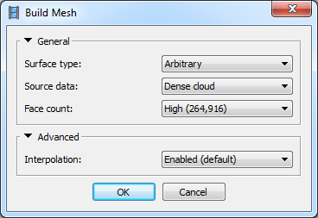

    - Click Add
    - Select Build Texture Proper texture mapping mode selection helps to obtain optimal texture packing and, consequently, better visual quality of the final model.

Recommended Values:
Mapping mode: Generic

Blending mode: Mosaic

Texture size/count: 4096 x 1 (width and height of the texture atlas in pixels and determines the number of files for texture to be exported to. Exporting texture to several files allows to archive greater resolution of the final model texture, while export of high resolution texture to a single file can fail due to RAM limitations)

Enable color correction: disabled (the feature is useful for processing of data sets with extreme brightness variation, but for general case it could be left unchecked to save the processing time)

    - Click OK

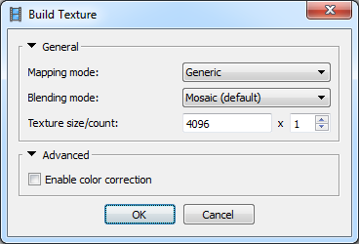

    - Click Add

    - Select Build Tiled Model
Tip: Hierarchical tiles format is a good solution for city scale modeling. It allows for responsive visualisation of large area 3D models in high resolution, a tiled model being opened with Agisoft Viewer - a complementary tool included in PhotoScan installer package.
Keep default settings
    - Click OK
    - Click Add
    - Select Build DEM
Tip: A Digital Elevation Model (DEM) represents a surface model as a regular grid of height values.
Select source data for DEM rasterization.
    - Click OK
    - Click Add
    - Select Build Orthomosaic
Tip: Orthomosaic export is normally used for generation of high resolution imagery based on the source photos and reconstructed model. The most common application is aerial photographic survey data processing, but it may be also useful when a detailed view of the object is required.
Keep default settings
    - Click OK
    - Confirm Save project after each step check box is checked
    - Click OK
    - Save project to appropriate folder
    - Name project and click Save

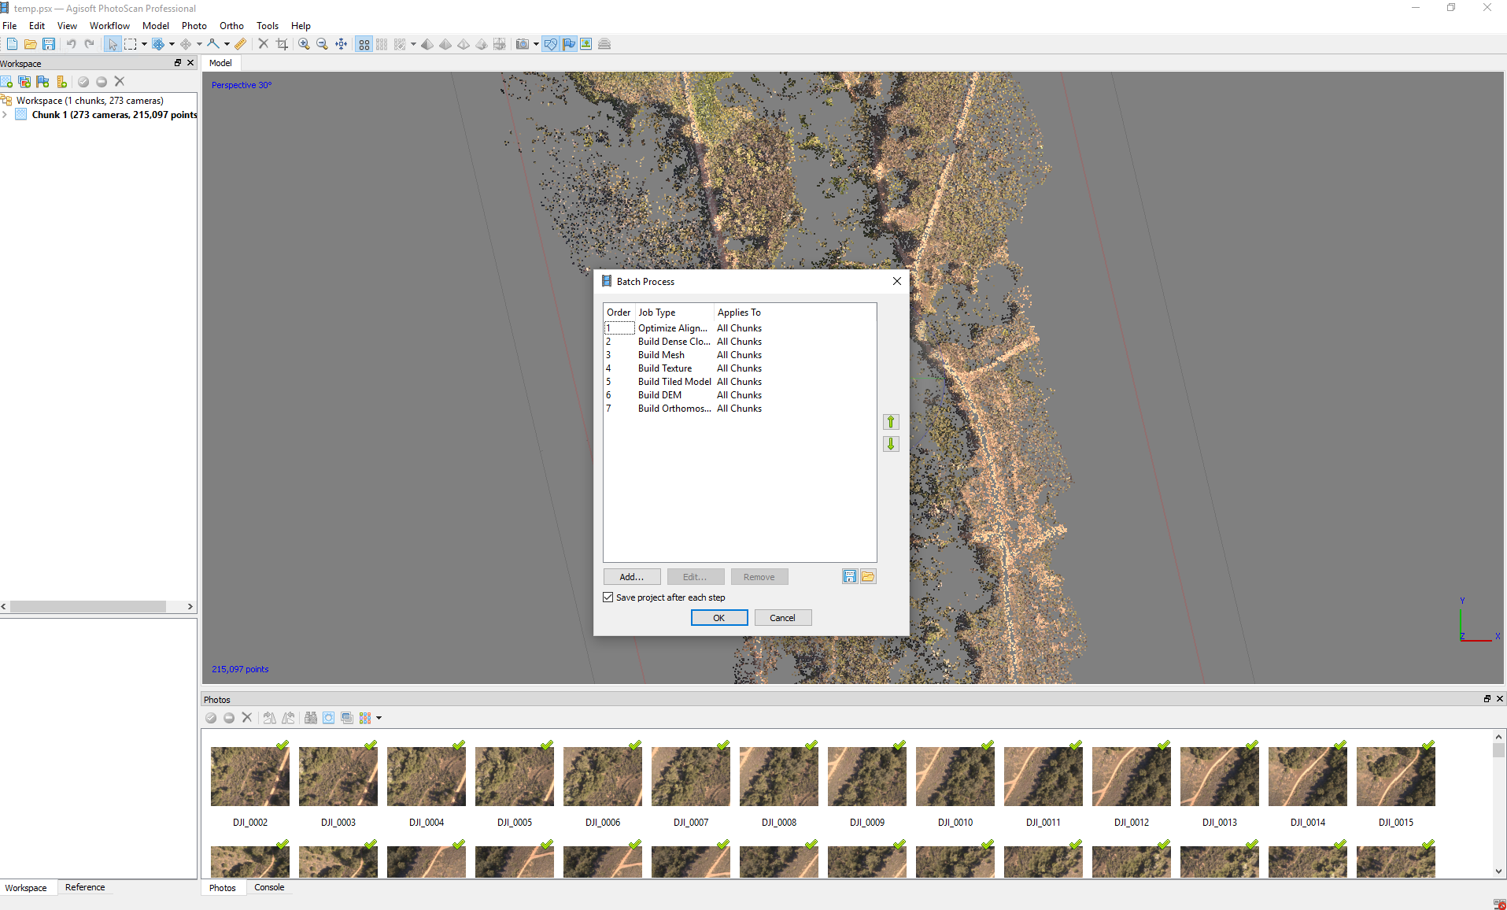
  - Exporting Orthomosaic
    - Click File
    - Select Export Orthomosaic
    - Select Export JPEG/TIFF/PNG
Tip: TIFF compression and JPEG quality should be specified according to the job requirements. BigTIFF format allows to overcome the TIFF file size limit for the large orthomosaics, but it is not supported by some applications.
    - Check Write KML file and / or Write World file options to create files needed to georeference the orthomosaic in the Google Earth and/or a GIS.
    - Save project to appropriate folder
    - Name project and click Save

  - Exporting DEM
    - Click File
    - Select Export DEM
    - Select Export TIFF/BIL/XYZ
Tip: File type should be specified according to the job requirements.
    - Check Write KML file and/or Write World file options to create files needed to georeference the DEM in the Google Earth and/or a GIS.
    - Save project to appropriate folder
    - Name project and click Save

  - Export 3D model
    - Click File
    - Select Export Model
    - Choose the file type according to the job requirements.
    - Save project to appropriate folder
    - Name project and click Save
Note: If a model generated with PhotoScan is to be imported in a 3D editor program for inspection or further editing, it might be helpful to use Shift function while exporting the model. It allows to set the value to be subtracted from the respective coordinate value for every vertex in the mesh. Essentially, this means translation of the model coordinate system origin, which may be useful since some 3D editors, truncate the coordinates values up to 8 or so digits.
REFERENCES
Agisoft LLC. (2016). Agisoft PhotoScan User Manual: Professional Edition, Version 1.2
Retrieved from http://www.geocom.cl/assets/photoscan-pro_1_2_en.pd

This resource was created with support from the National Science Foundation under Grant ATE #1700552. Any opinions, findings, and conclusions or recommendations expressed in this material are those of the author(s) and do not necessarily reflect the views of the National Science Foundation.

Attribution-NonCommercial-ShareAlike
CC BY-NC-SA

